Promasidor Ghana (PGH) rewards its top performing distributors at the 2024 PGH Partners Dialogue & Awards
Promasidor Ghana (PGH) over the weekend honored its top performing distributors at its annual Partners Dialogue & Awards event held at the plush Labadi Beach Hotel in Accra. The event was in two-fold; Business Meeting in the morning and Awards/Gala Night in the evening. The morning session provided an opportunity to review 2023 performance and communicate volume projection with action plan for 2024. Also, there were presentations from three (3) financial institutions namely ABSA, UBA and Access Bank on tailor-made financial support and facility that our distributors can leverage on. We wrapped up the session with a Town Hall meeting.
Managing Director, Mr. Festus Tettey in his welcome address at the Award Night, shared his heartfelt gratitude to the distributors for their continuous dedication and commitment to the common values and goals shared as business partners. He encouraged the partners to adopt the best management practices in their business operations and uphold the highest possible standards that will protect the integrity and ensure the continuity of the businesses despite any obstacle. Mr. Tettey also took the opportunity to congratulate all awardees for standing out in their performance and urged other distributors to strive for such feat in the future.
Several awards were presented at brand, area, and national levels. Tonifel Enterprise, Accra East emerged as the 2023 Overall National Best Distributor and took home the ultimate prize of a KIA truck while the 2nd and 3rd position went to Maaltima Enterprise (North) and Kranby Enterprise (Accra East) respectively. Special awards were presented to Sheridash Enterprise who received the National Fastest Growing distributor for the year. Some of the distributors in their commentaries after the event, shared their excitement about the awards event and thanked Promasidor for the token of appreciation and further pledged their commitment to the business.

Enjoy moments captured in photos
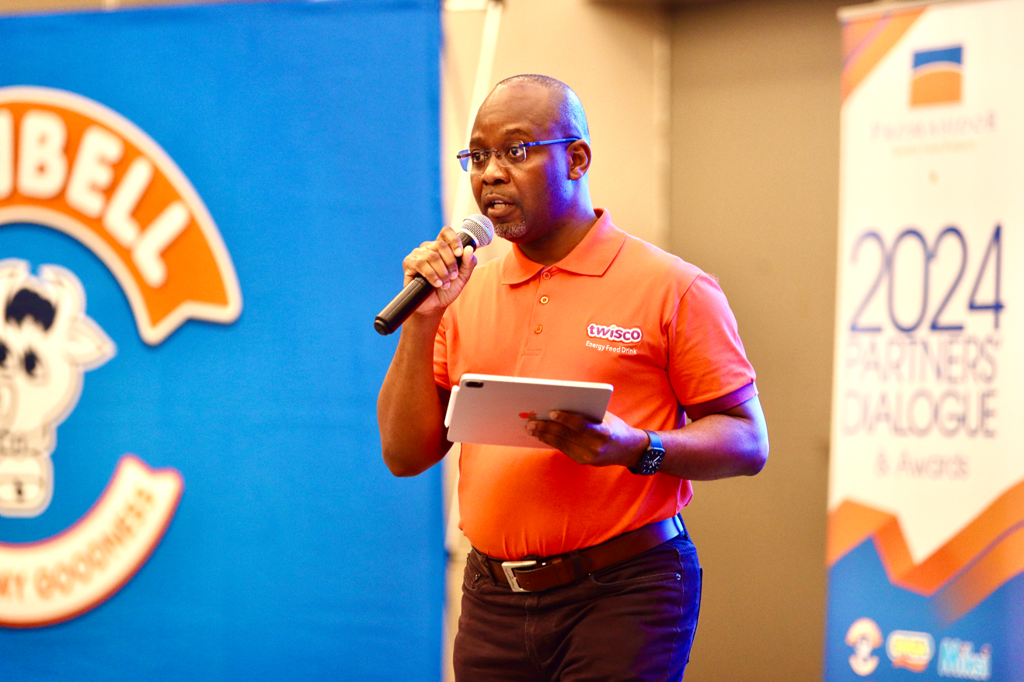

Managing Director- Mr. Festus Tettey gives an overview on 2023 business performance.

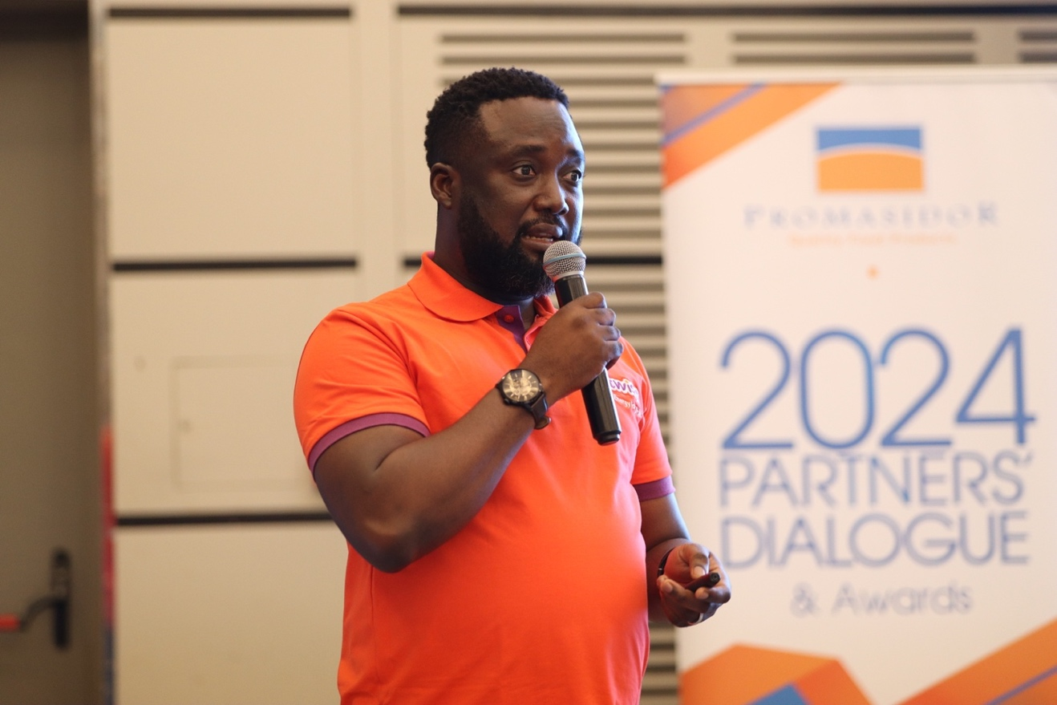

Commercial Director- Mr. Abiodun Ayodeji gives an overview of 2024 Strategic Direction


A Presentation from a representative of ABSA bank.

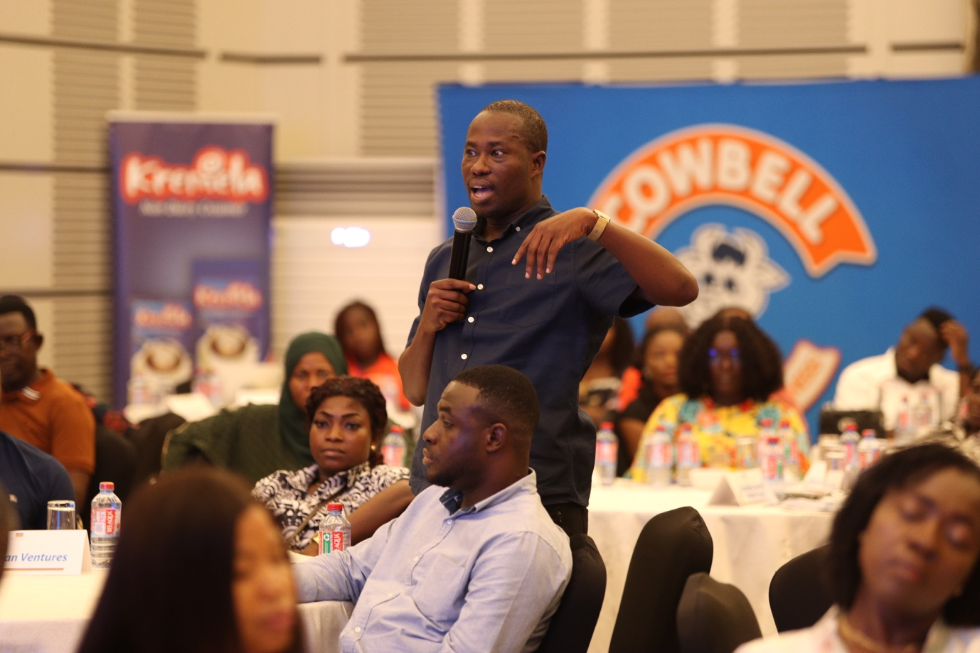
A distributor making an enquiry and contribution during the Partners’ Dialogue

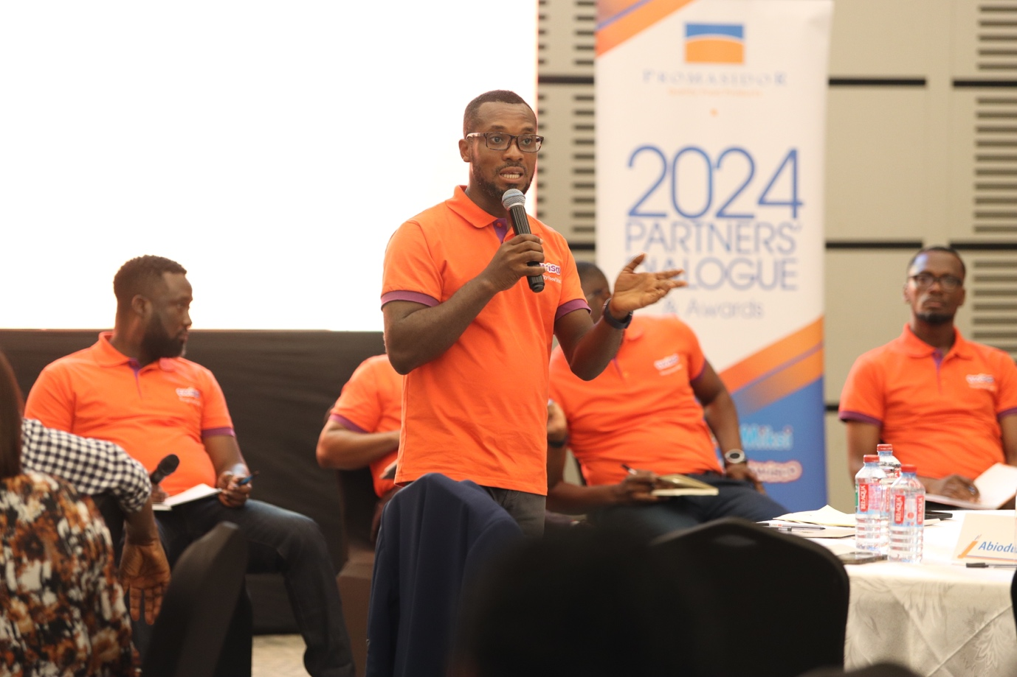

Sales Control Manager, Mr. Happy Dzah addressing distributors during the Town Hall meeting.



Dialogue

MCs: Gideon Kodo and Jacinta Ocansey welcoming the guests to the Partners Awards Ceremony

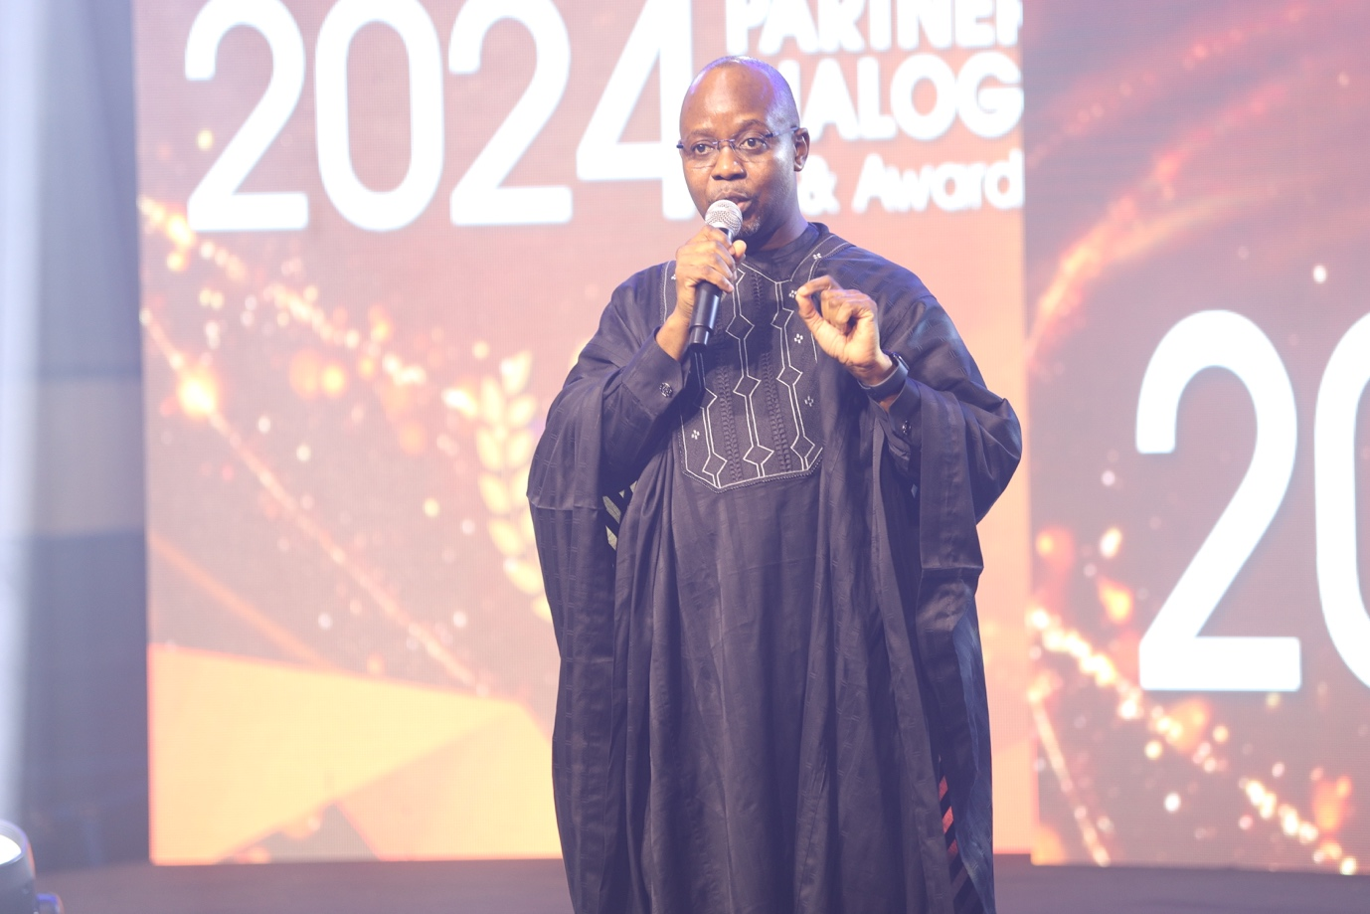

Managing Director – Mr. Festus Tettey delivering his welcome address.

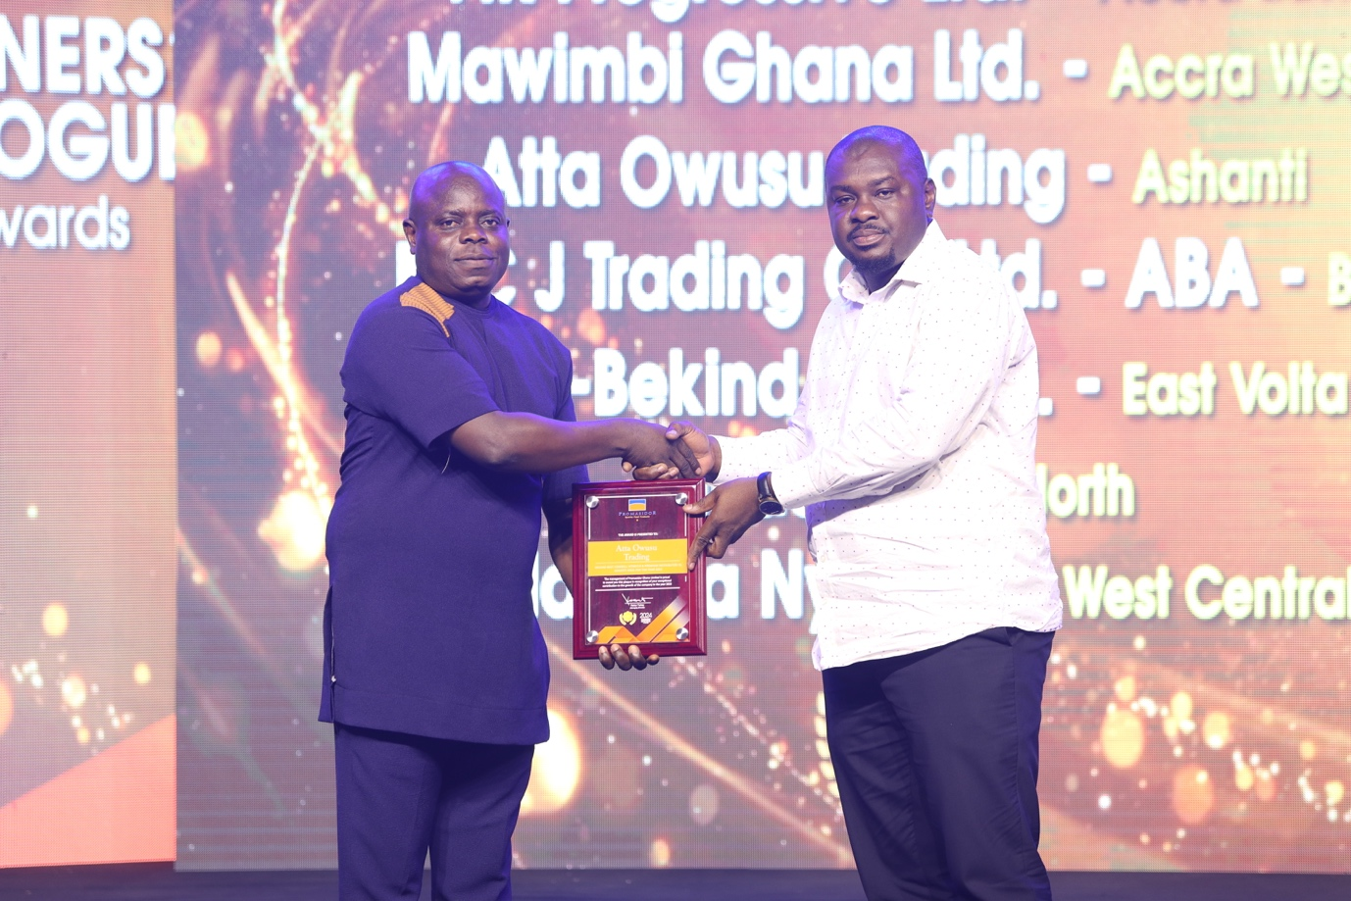

Ashanti based ‘Atta Owusu Trading’ receiving award for 2nd Best Cowbell VitaRich/Premium Distributor

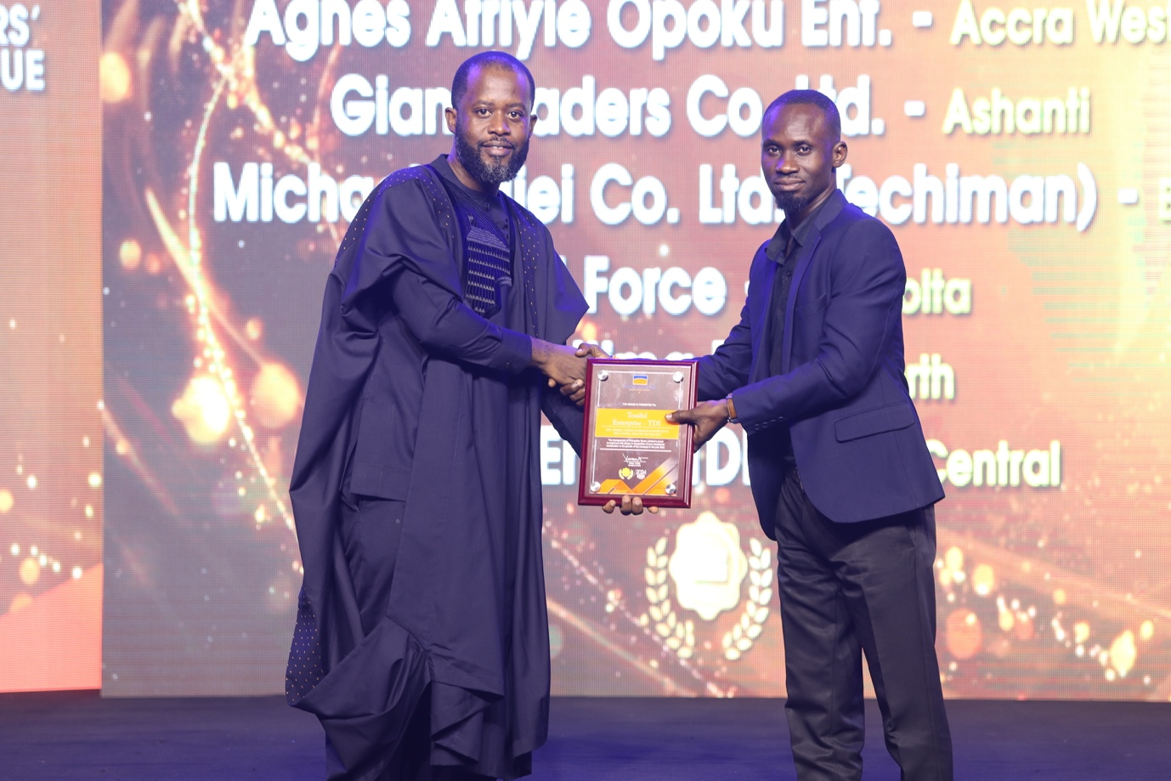

Accra East based Tonifel Enterprise receiving award for Best Cowbell VitaRich/Premium Distributor

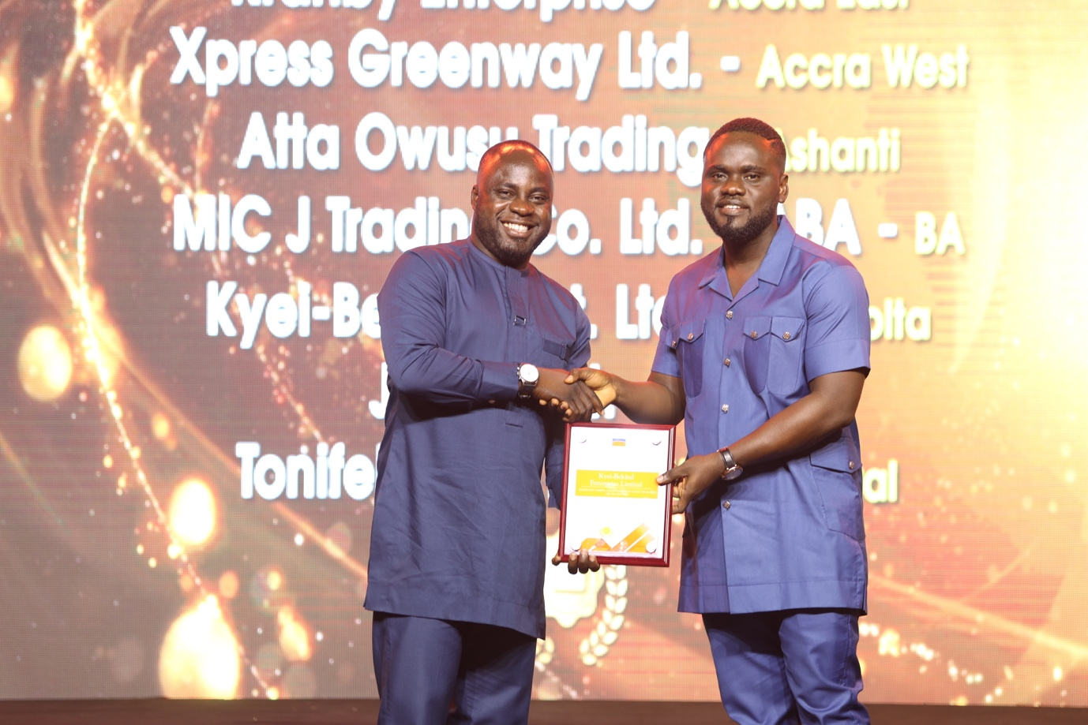

East Volta based, Kyei-Bekind receiving award for 2nd Best Cowbell Coffee Distributor

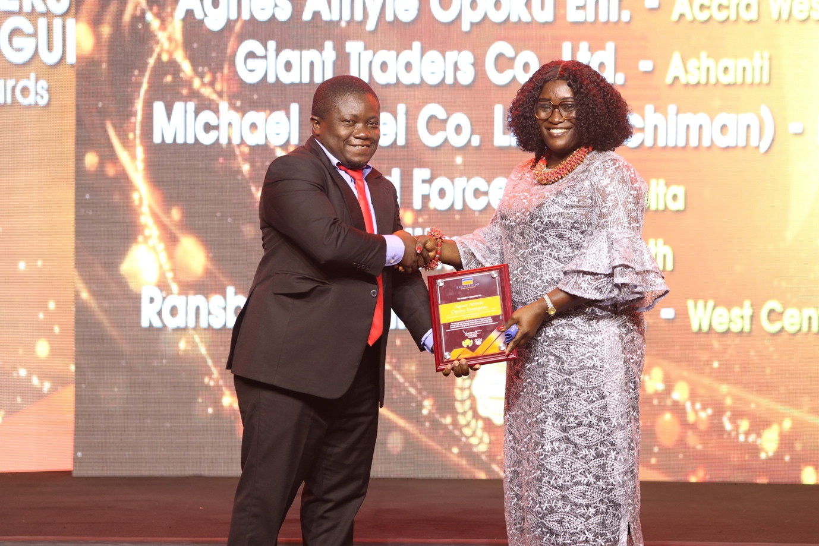

Accra West based Agnes Afriyie Opoku Ent receiving award for Best Cowbell Coffee Distributor

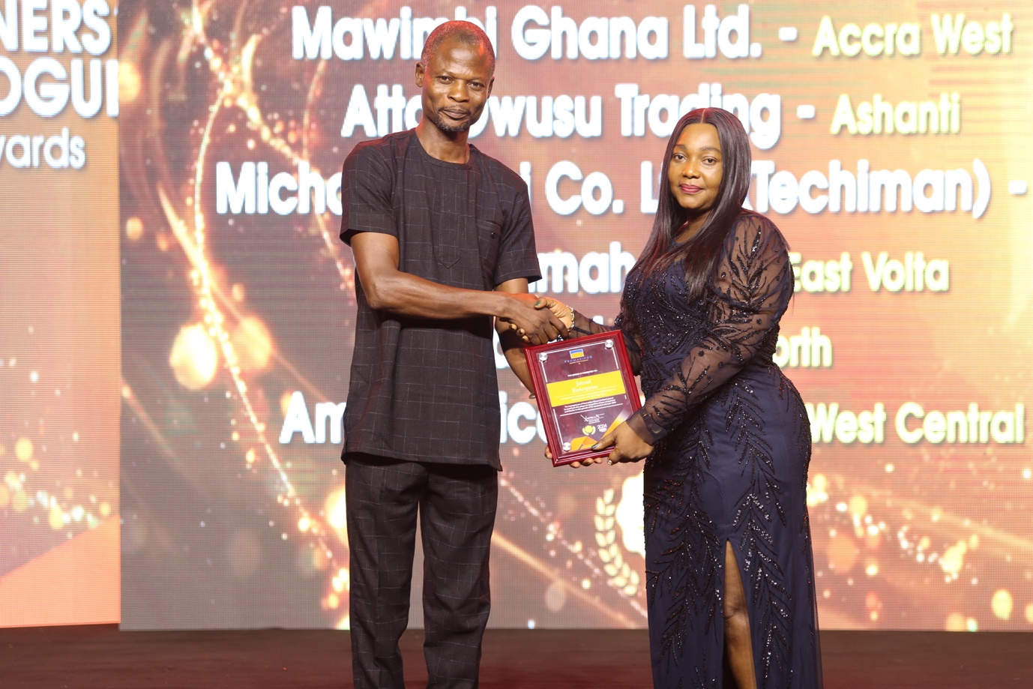
North based ‘Jatrad’ receiving award for 2nd Best Cowbell Flavours Distributor

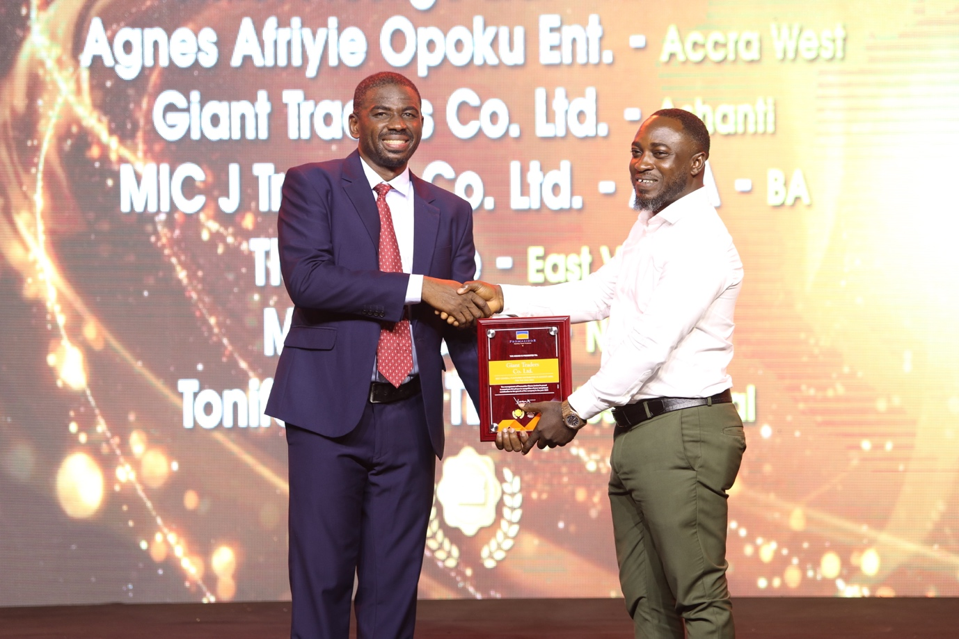

Ashanti based Giant Traders receiving award for Best Cowbell Flavours Distributor.

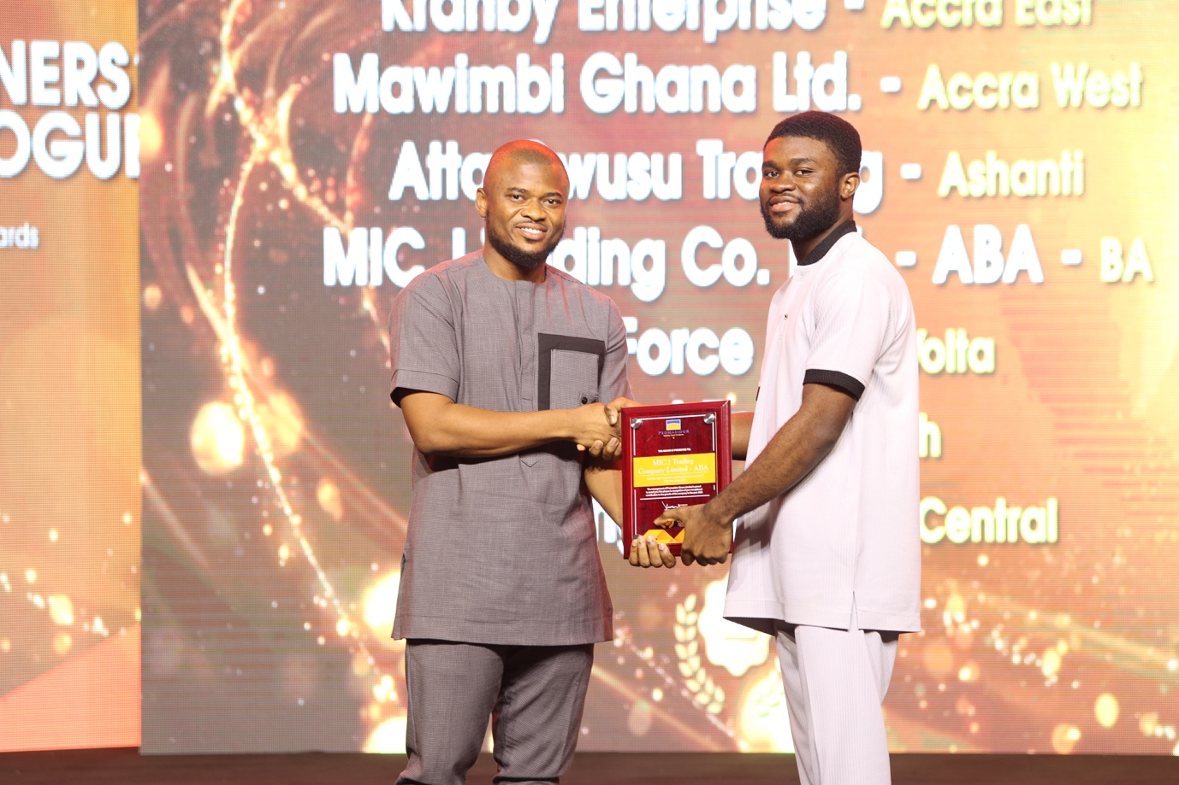

Brong Ahafo based Mic Jay Trading Company Ltd- ABA receiving award for 2nd Best Kremela Distributor.

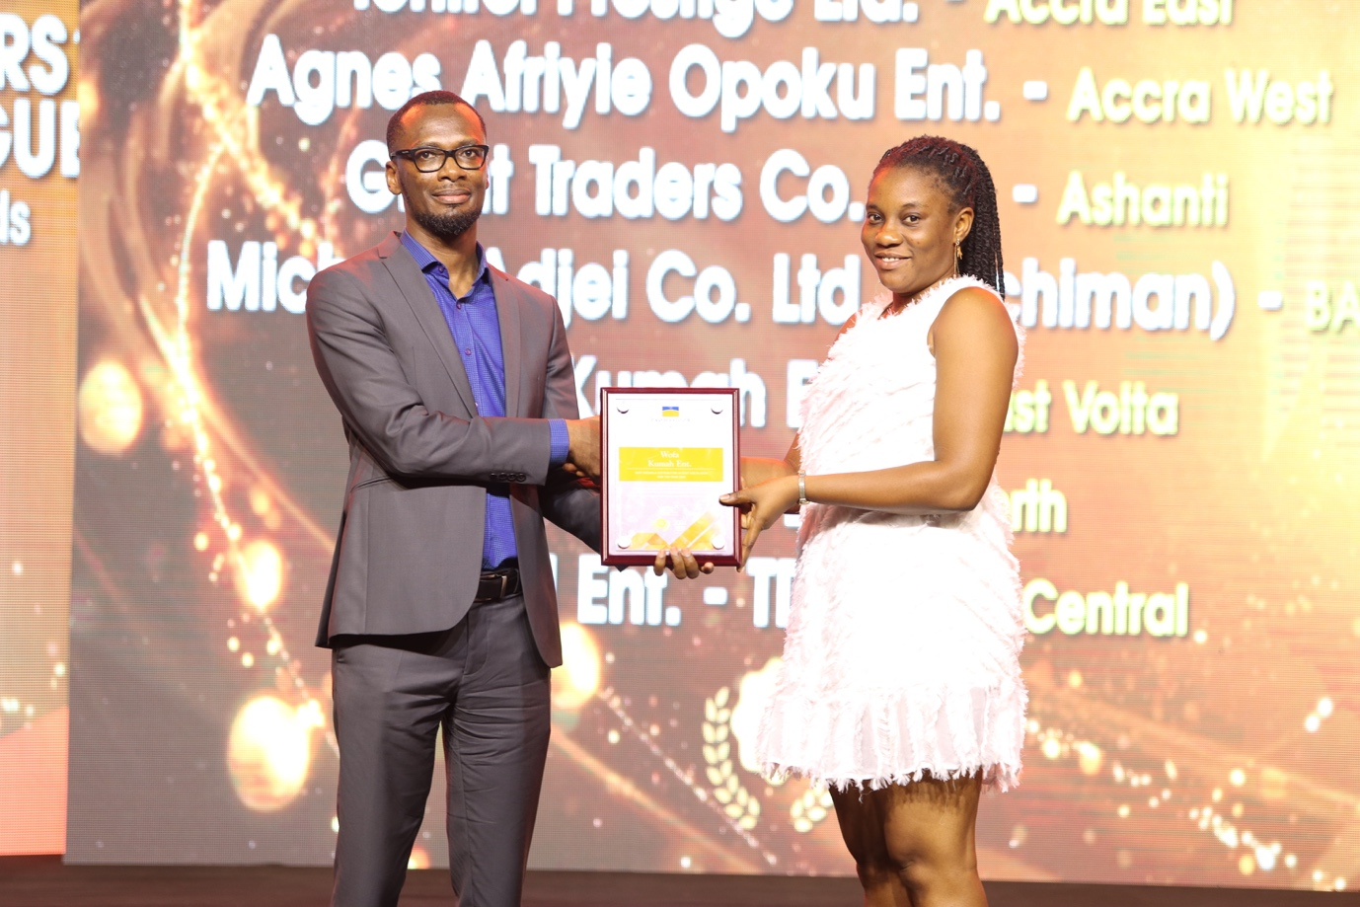

East Volta based, Wofa Kuma Enterprise receiving award for Best Kremela Distributor.

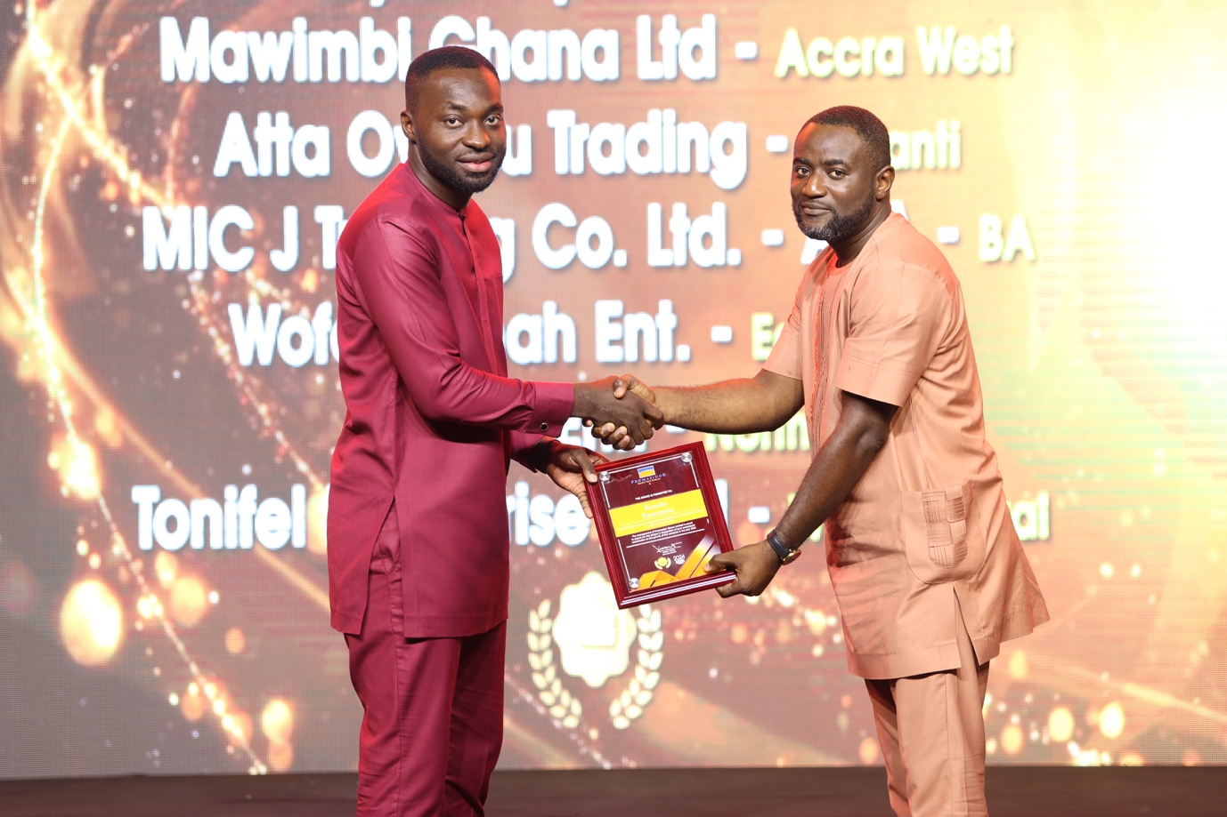

Accra East based Kranby Enterprise receiving award for 2nd Best Miksi Flavours Distributor.
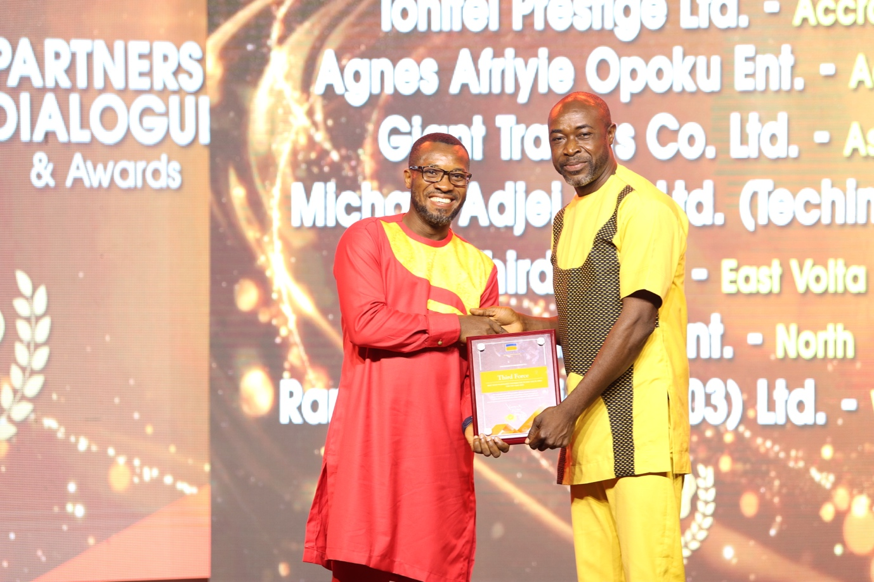

East Volta distributor Third Force receiving award for Best Miksi Flavours Distributor.

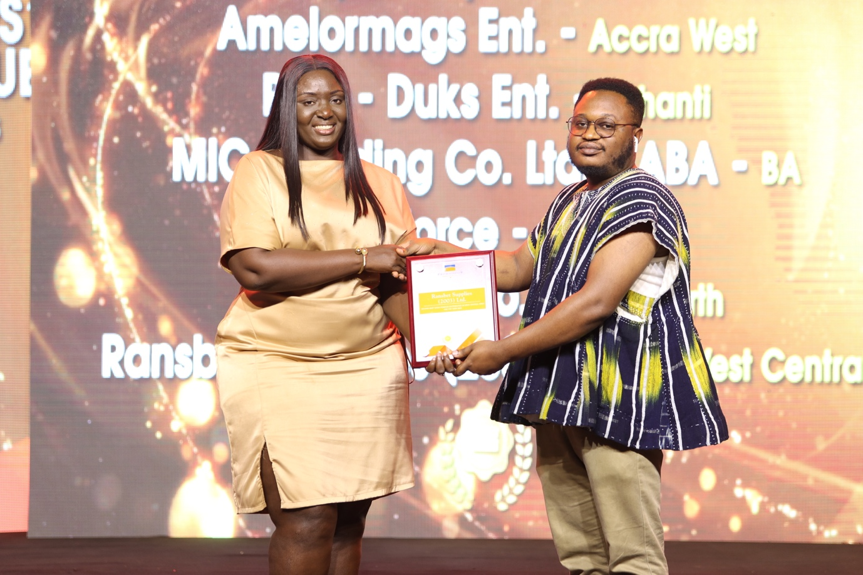

West Central based Ransbet Supply 2003 Ltd receiving award for 2nd Best Onga Powder Distributor.

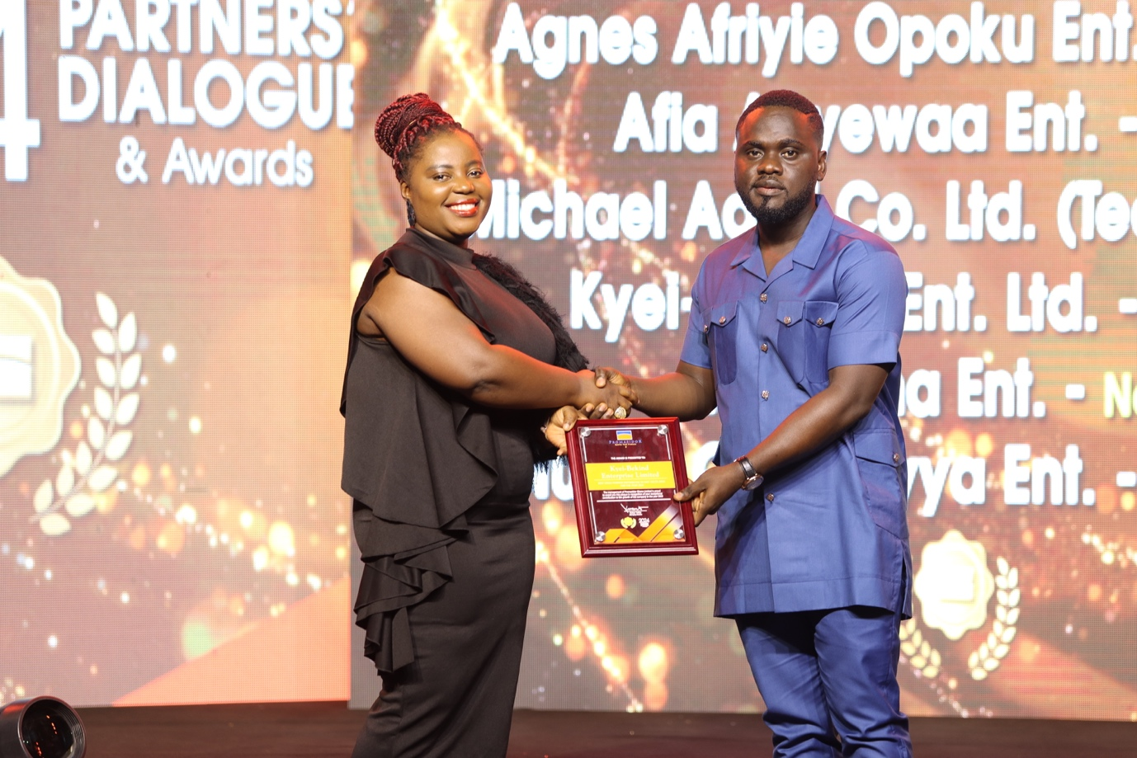

East Volta based Kyei Be-Kind Enterprise receiving award for Best Onga Powder Distributor.

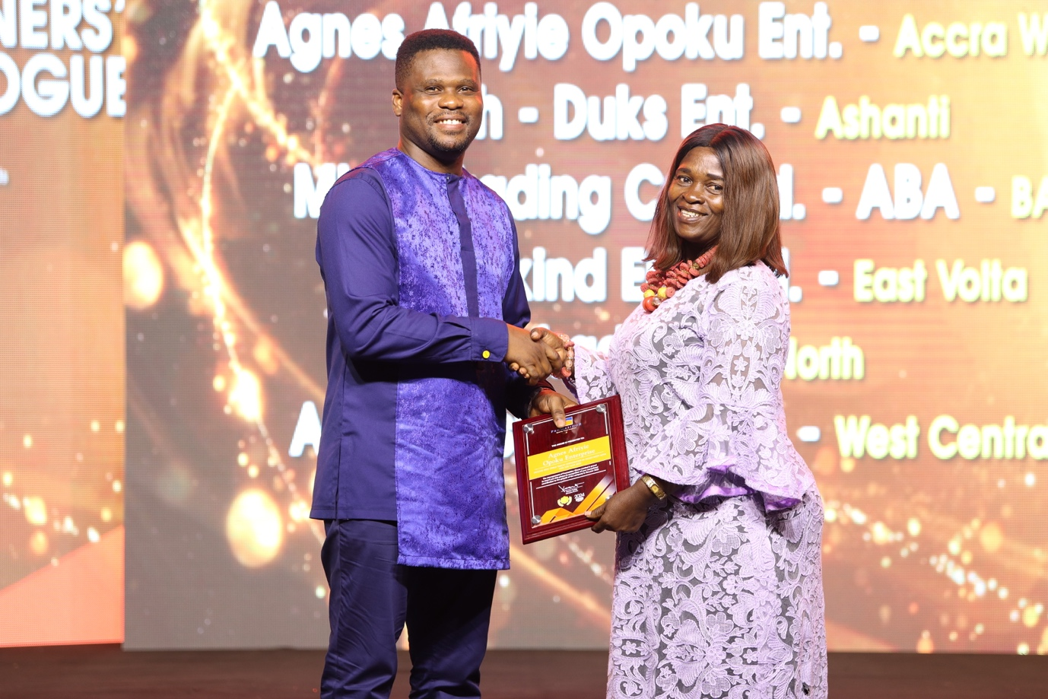

Accra West based Agnes Afriyie Opoku Enterprise’ receiving award for 2nd Best Onga Tablet Distributor.

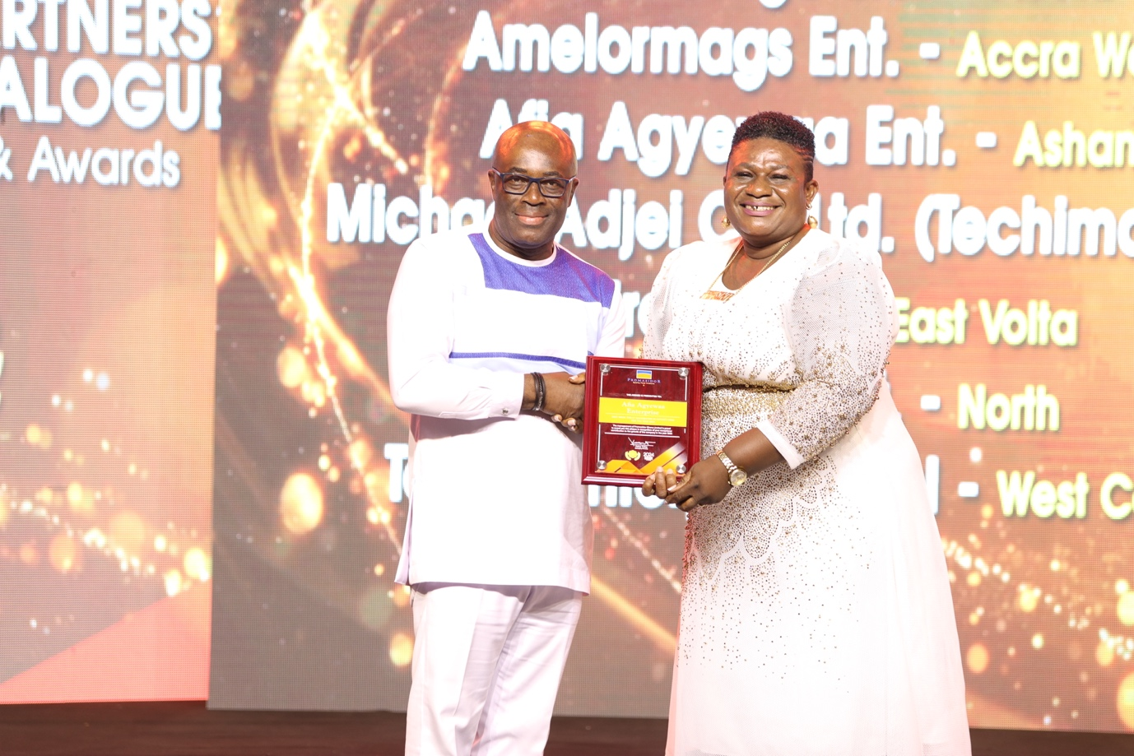

Ashanti based ‘Afia Agyewaa Enterprise’ receiving award for Best Onga Tablet Distributor

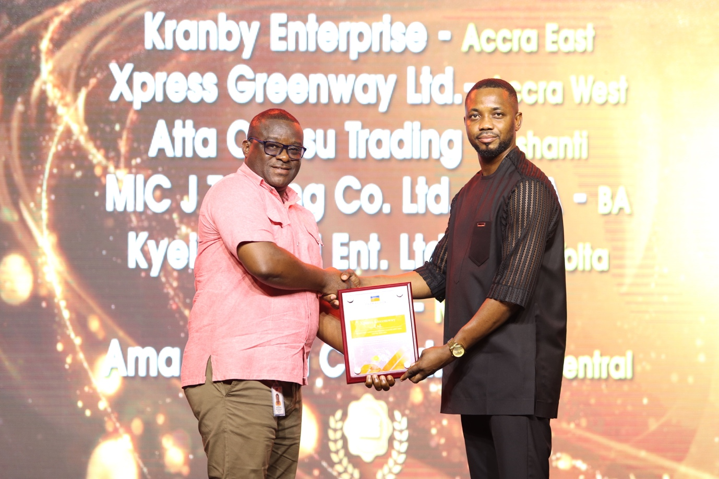

Accra West based Xpress Greenway Limited receiving award for 2nd Best Yumvita Distributor
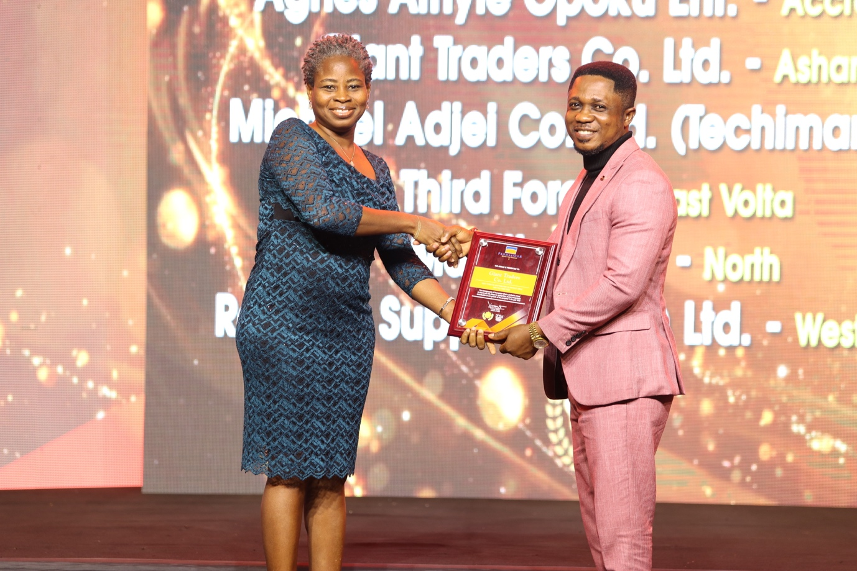

Ashanti based Giant Traders Limited receiving award for Best Yumvita Distributor

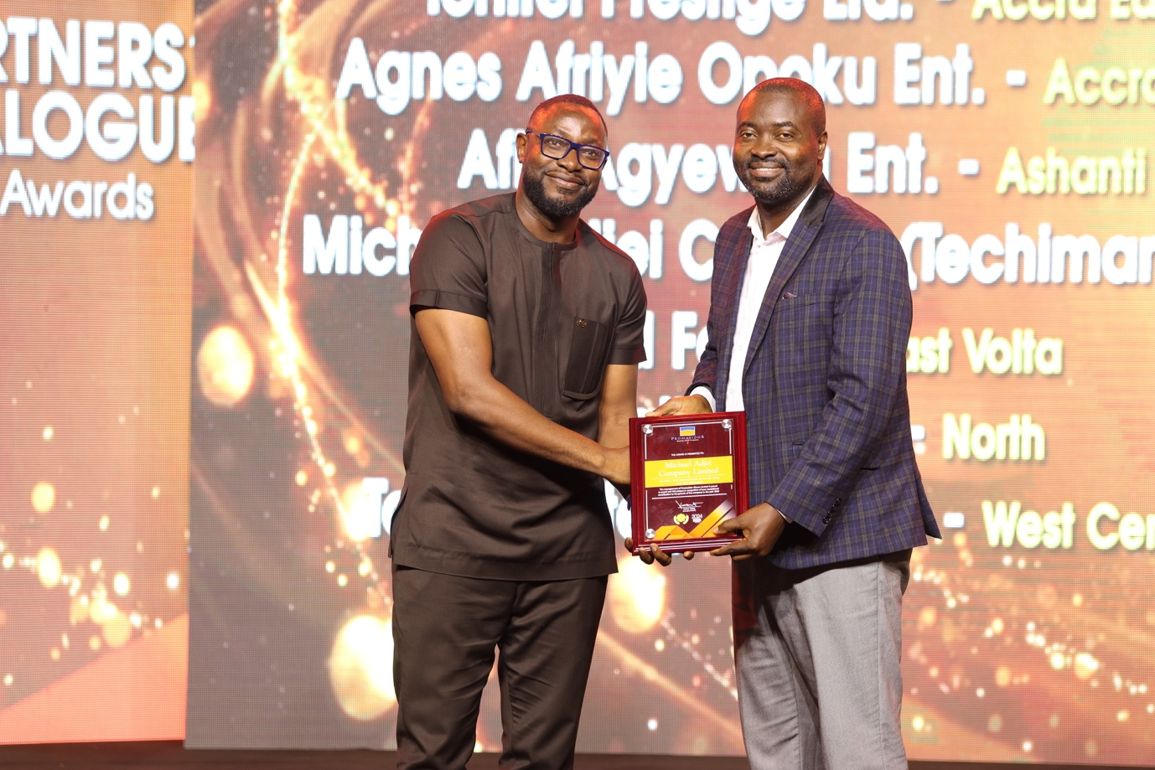

Brong Ahafo distributor, Michael Adjei Limited receiving award for Area Best Distributor
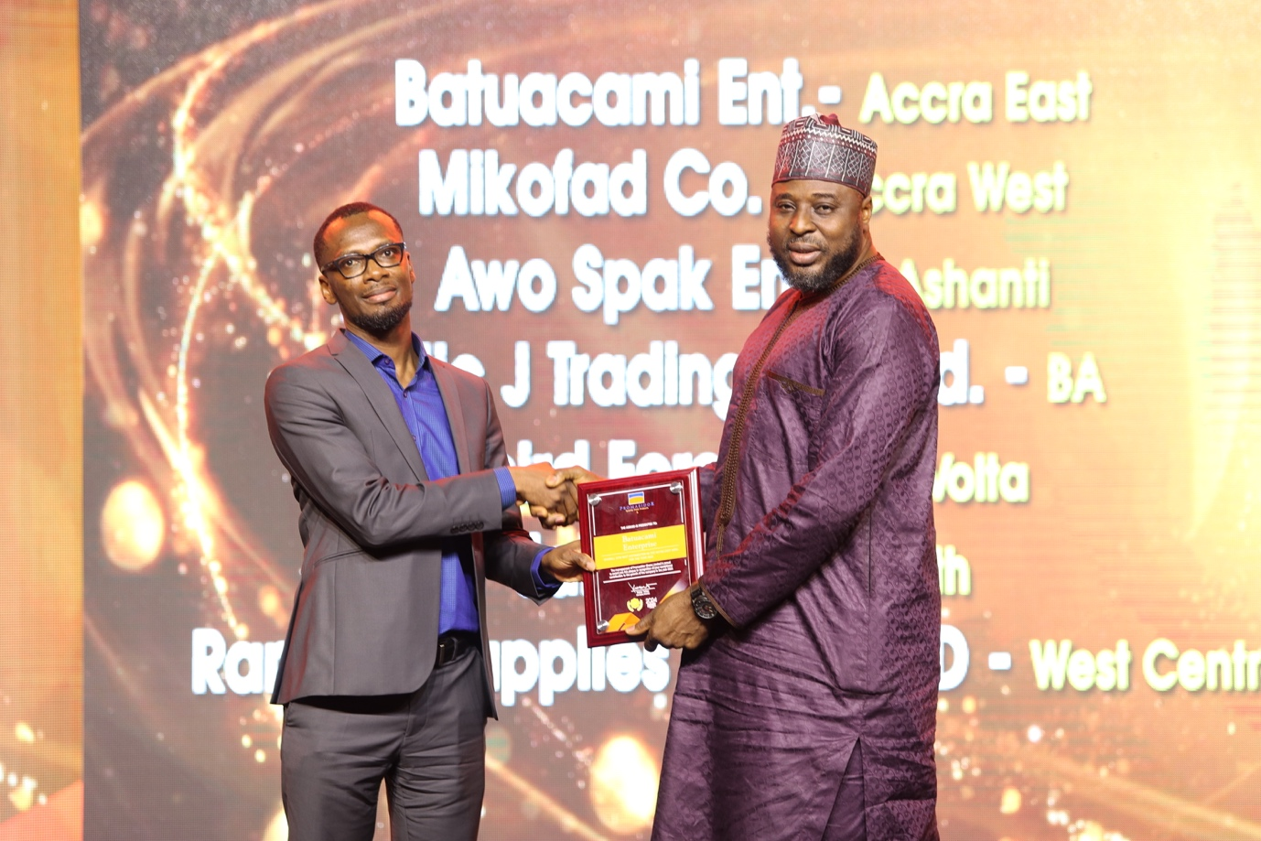

Accra East based, Batucami Enterprise receiving award for GTM Area Best Distributor.

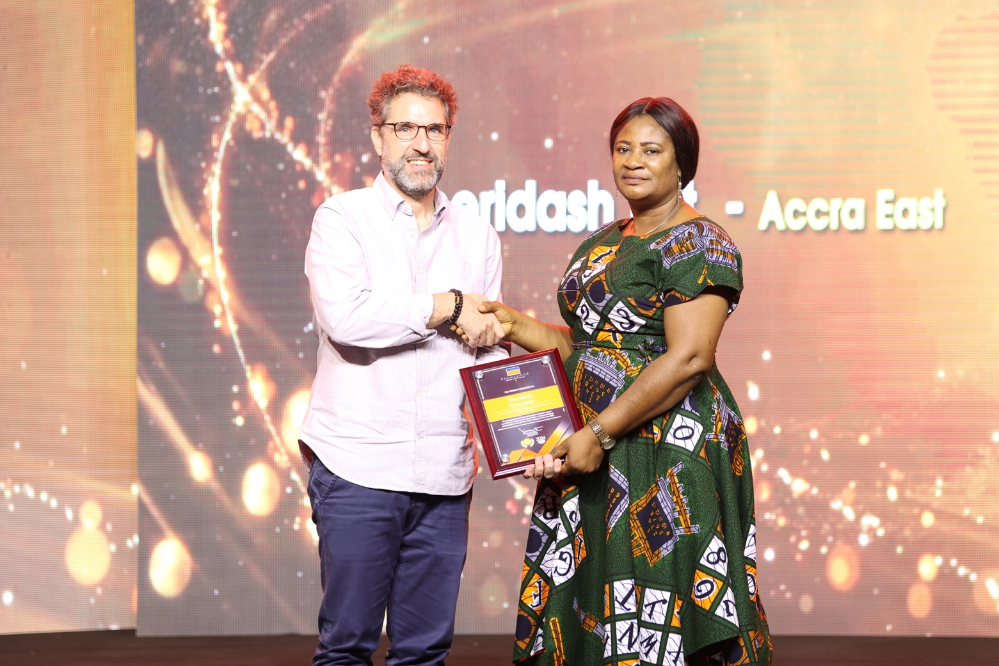

Sheridash Enterprise receiving award for Fastest Growth Distributor
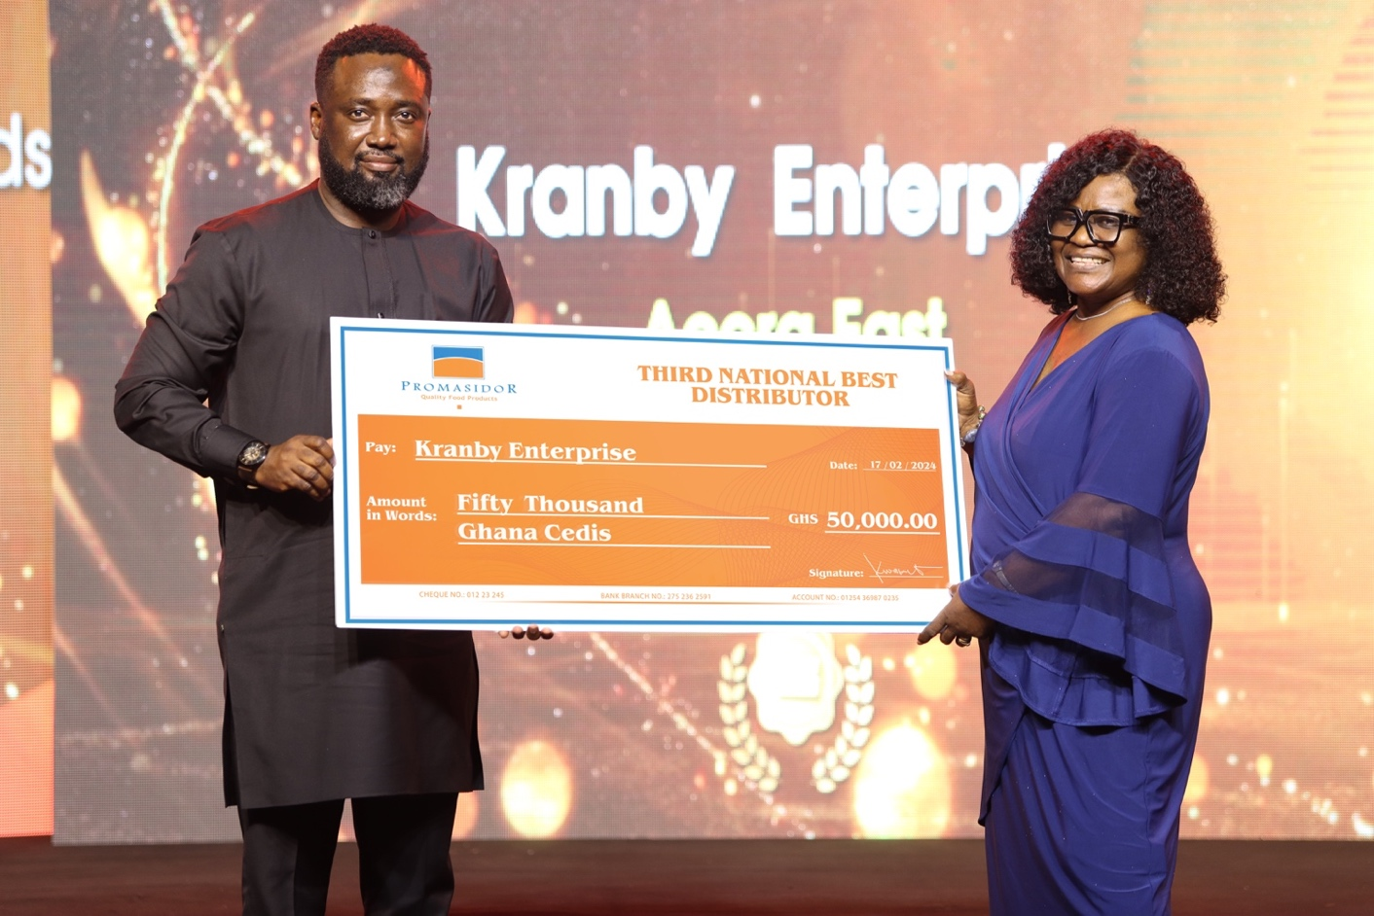

National Best Distributor- 3RD. Position, Kranby Enterprise receives prize from Commercial Director, Mr. Abiodun Ayodeji.

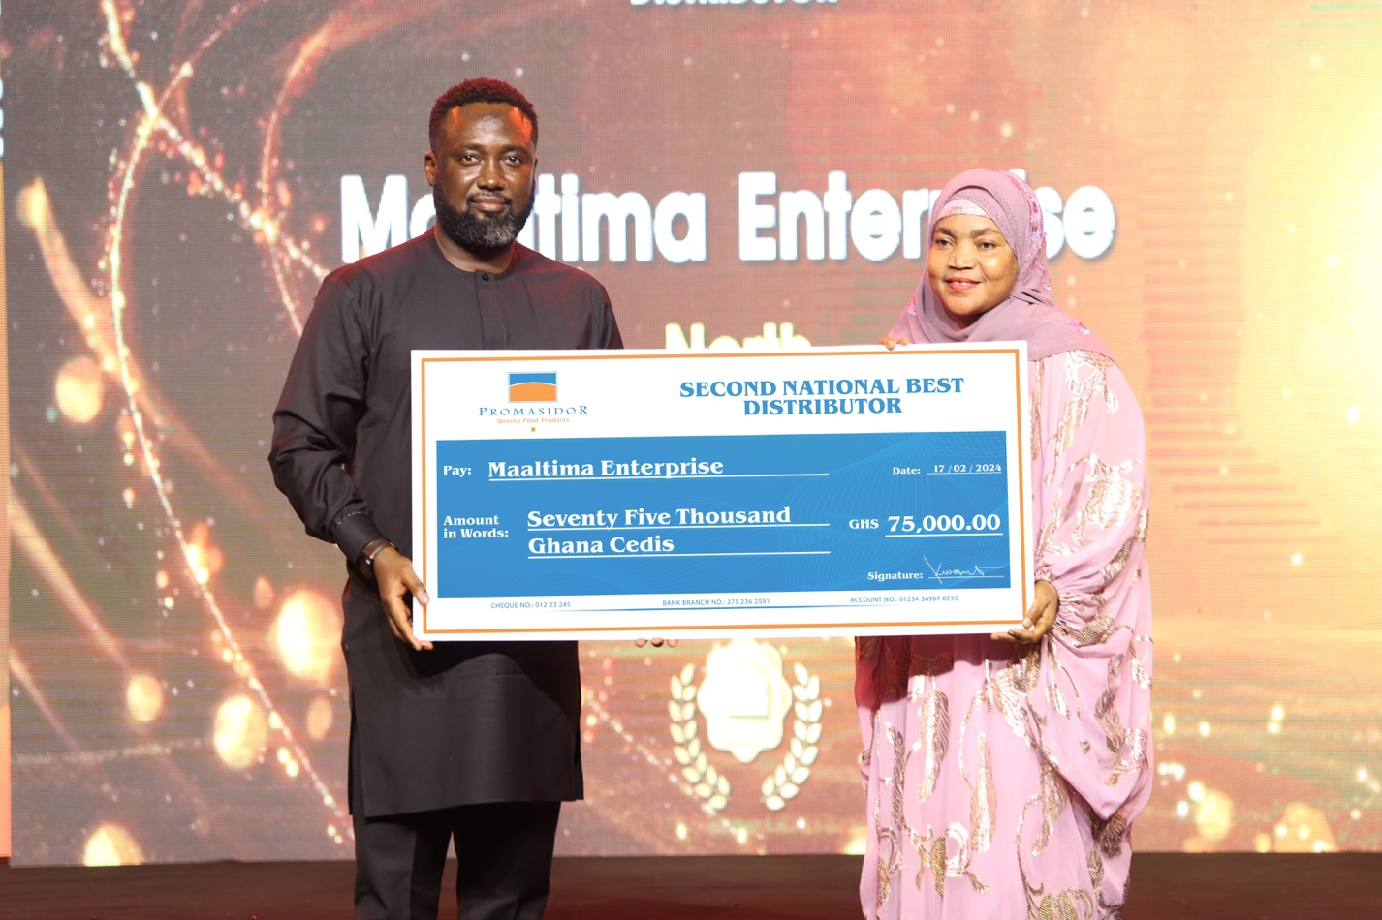

National Best Distributor 2nd Position, Maaltima Enterprise receives cash prize from Commercial Director, Mr. Abiodun Ayodeji.
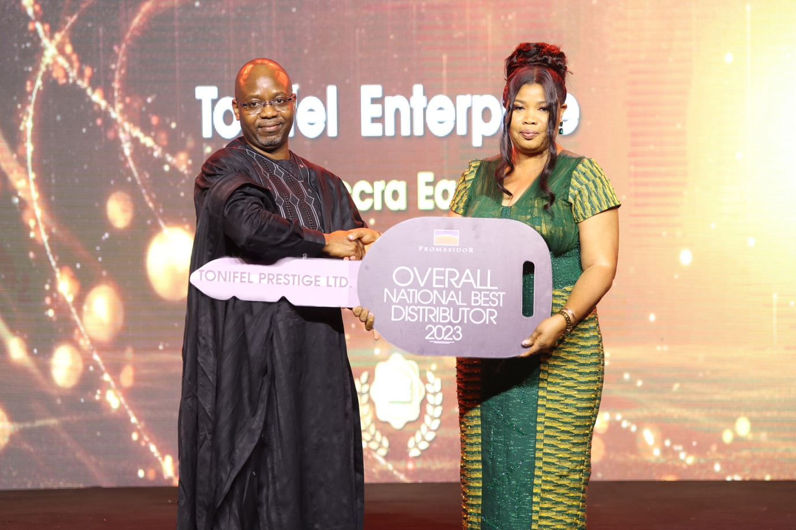

Managing Director, Mr. Festus Tettey, presents car prize to Overall National Best Distributor to Tonifel Prestige Limited.

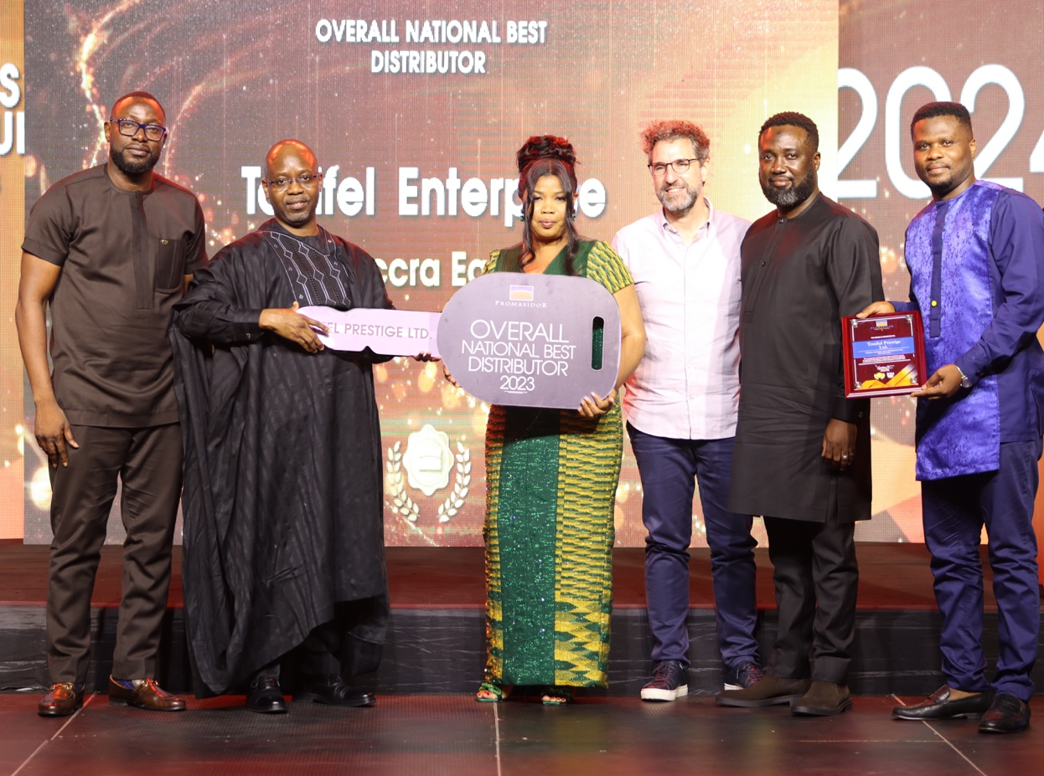

A group photo with Overall National Best Distributor

