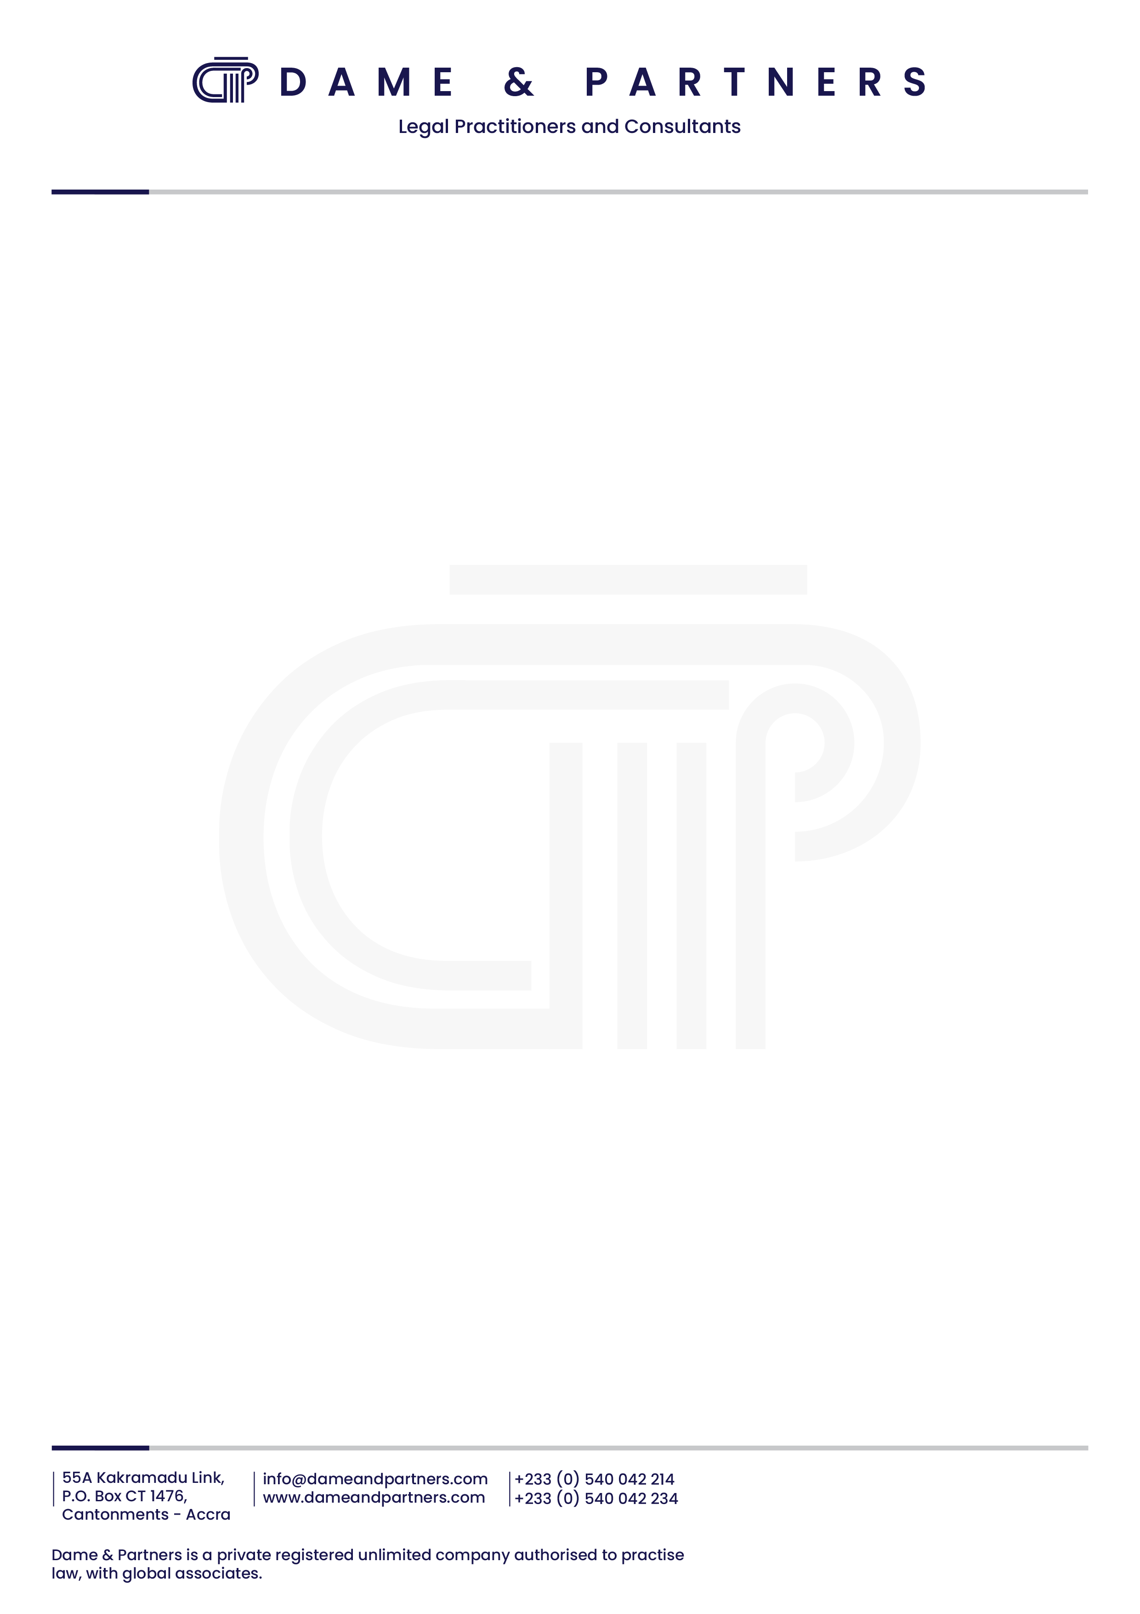

5th July, 2026
TO ALL MEDIA HOUSES
PRESS RELEASE!!!

RE: UNLAWFUL ARREST OF HANAN ABDUL-WAHAB AT THE AIRPORT, ACCRA DESPITE COURT ORDER

The attention of the firm of Messrs. Dame & Partners has been drawn to a Facebook post by the Deputy Attorney-General and Deputy Minister for Justice, Dr. Srem Sai, on 4th July, 2026 purporting to justify an unlawful arrest of Hanan Abdul-Wahab (our client) after having been granted permission to travel to the United Kingdom, by an order of the High Court, Accra dated 29th June, 2026.

The said Facebook post, laden with falsehood, was a lame attempt to cover up the Attorney-General’s deplorable authorisation for an order of a court of competent jurisdiction to be violated with impunity. We set out the true facts.

- Following an application filed by his lawyers, our client, Hanan Abdul-Wahab, was permitted by the High Court presided over by His Lordship Justice Achibonga, Justice of the Court of Appeal (sitting as an additional High Court Judge), to travel for an appointment with his Optician from 4th July to 12th July, 2026. This was after the Judge had considered arguments from counsel in the matter including Dr Srem Sai.

- The order of the court was consistent with precedent permitting accused persons on trial to travel in exercise of their fundamental human right to freedom of movement and right to medical care. The record shows that in the recent past, persons standing trial for similar offences as our client - Dr. Stephen Opuni, Seidu Agongo, Alhaji Collins Dauda, Dr. Cassiel Ato Forson, Dr Kwabena Duffuor and many others - were regularly permitted by the court to travel in and out of the country whilst standing trial.

- The allegation by the Deputy Attorney-General that our client

attempted “to use false means to empty his frozen bank account with Republic Bank ...” is simply untrue. We challenge him to produce evidence of a withdrawal of any sum by our client from any of his bank account since the date of the court order.

- In any event, there is no valid order of any court of competent jurisdiction freezing our client’s accounts. Our client’s accounts were frozen last year pursuant to investigations which resulted in his earlier arrest and prosecution. On 5th May, 2026, the charges against our client were withdrawn leading to his discharge. This resulted in a lapse of all orders made by the High Court, relating to bail and freezing orders, in respect of his earlier prosecution.

- On 15th May, 2026, fresh charges were filed by the Republic against our client. On 20th May, 2026, the High Court, Adentan, presided over by His Lordship Justice Kwame Osei Gyamfi, held that “the re-arrest began a fresh process” and implied that “there is no valid freezing order” in place. We have explained the true position of the law in a formal letter delivered to the Executive Director of the Economic and Organised Crimes Office (EOCO) about 2 weeks ago.

- It is thus grossly deceptive and misleading for the Attorney-General and his Deputy to deploy the Bureau of National Investigations (BNI) to arrest our client based on a false allegation of an attempt to withdraw money from a frozen bank account (evidence of which does not exist).

- We consider the development very serious as it confirms our suspicion that the Attorney-General and his Deputy are the masterminds of the frequent violations of court orders by law enforcement agencies and the persistent harassment of our client and other citizens of Ghana under the current administration. We will accordingly institute proceedings for contempt of court against the Attorney-General, his Deputy and the Director of BNI for this blatant and wilful violation of an order of a court of competent jurisdiction. Freedom, in fact, has become a rare and expensive commodity!
END!!!

SGD
GODFRED YEBOAH DAME
Counsel for Hanan Abdul-Wahab.

